

TENTATIVE EFI EVENTS CALENDAR - 2025
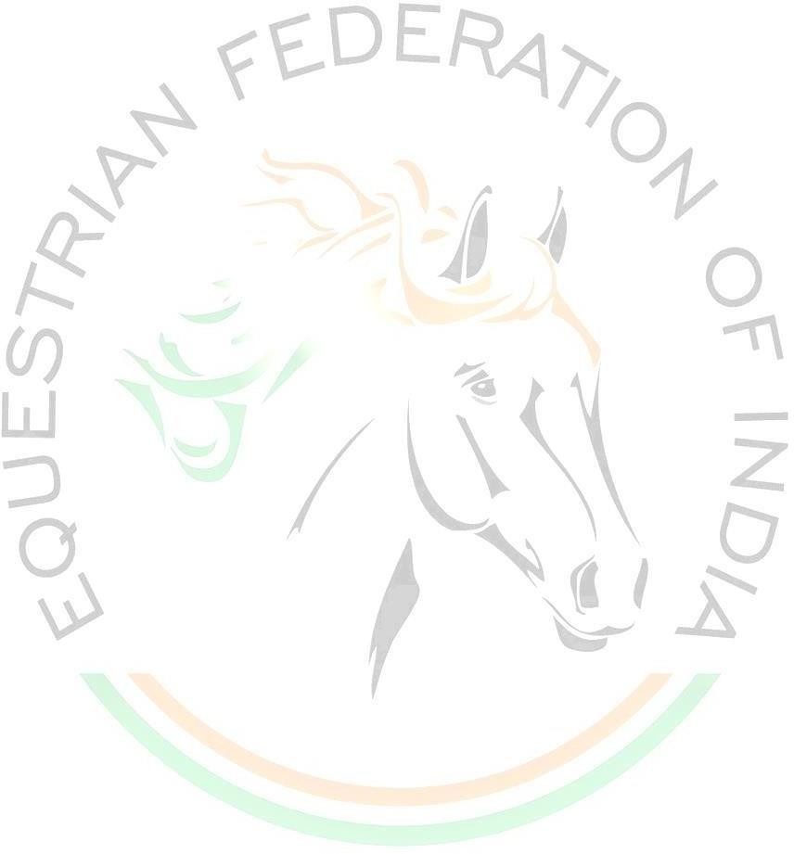
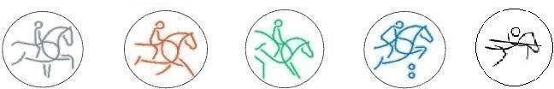
S.  No | Tentative Dates | Event Status & Disciplines | Events | Venue | Organiser | Remarks
1 | 02 Apr 2025  05 Apr 2025 | FEI -  Jumping | Concours de Saut International 1*, Junior & Senior | - | -
2 | 08 Apr 2025  11 Apr 2025 | EFI CDN-  Dressage | Concours de Dressage National | - | -
3 | 09 Apr 2025  11 Apr 2025 | FEI CDI –  Dressage | Concours de Dressage International1* | - | -
4 | 12 Apr 2025 13 Apr 2025 | FEI –  PARA Dressage | Workshop on Para Dressage | - | -
5 | 23 Apr 2025  26 Apr 2025 | EFI Eventing | Introductory, Pre Novice & Novice | - | -
6 | 30 Apr 2025  04 May 2025 | FEI Eventing | CCI 1* (Intro), 2*-Short & 3*-Short | - | -
7 | 13 May 2025  14 May 2025 | Jumping | Selection Trial for AEF Cup CSI J (B) | - | -
8 | 15 May 2025  17 May 2025 | Jumping | AEF Cup CSI J (B) | - | -

2

S.  No | Tentative Dates | Event Status & Disciplines | Events | Venue | Organiser | Remarks
9 | 22 May 2025  25 May 2025 | FEI -  Jumping | Concours de SauInternational 1*, Children, Junior & Senior | - | -
10 | 28 May 2025  31 May 2025 | EFI CSN –  Jumping | Concours de Saut National 2* & 3* | - | -
11 | 08 Jun 2025  11 Jun 2025 | EFI CDN-  Dressage | Concours de Dressage National | - | -
12 | 09 Jun 2025  11 Jun 2025 | FEI CDI –  Dressage | Concours de Dressage International1* | - | -
13 | 02 Jul 2025  06 Jul 2025 | FEI Eventing | CCI 1* (Intro), 2*-Short & 3*-Short | - | -
14 | 15 Jul 2025  19 Jul 2025 | EFI CSN –  Jumping | Concours de Saut National 3* & 4* | - | -
15 | 24 Jul 2025  27 Jul 2025 | FEI -  Jumping | Concours de Saut International 1* | - | -
16 | 31 Jul 2025  03 Aug 2025 | EFI CDN-  Dressage | Concours de Dressage National | - | -

3
S.  No | Tentative  Dates | Event Status & Disciplines | Events | Venue | Organiser | Remarks
17 | 01 Aug 2025  03 Aug 2025 | FEI CDI –  Dressage | Concours de Dressage International1* | - | -
18 | 16 Aug 2025  19 Aug 2025 | EFI Eventing | Introductory, Pre Novice & Novice | - | -
19 | 24 Aug 2025  28 Aug 2025 | FEI Eventing | CCI 1* (Intro), 2*-Short & 3*-Short | - | -
20 | 28 Aug 2025  31 Aug 2025 | FEI -  Jumping | Concours de Saut International 1*, Children, Junior & Senior | - | -
21 | 02 Sep 2025  04 Sep 2025 | FEI World Challenge –  Eventing | Eventing World Challenge 2025 (South Zone) | - | -
22 | 04 Sep 2025  07 Sep 2025 | FEI -  Jumping | Concours de Saut International 1*, Children, Junior & Senior | - | -
23 | 05 Sep 2025  15 Sep 2025 | Regional Show- Jumping, Dressage & Tent Pegging | Sapta Shakti Horse Show | - | -

4

S.  No | Tentative Dates | Event Status & Disciplines | Events | Venue | Organiser | Remarks
24 | 11 Sep 2025 12 Sep 2025 | EFI CSN Show Jumping | Selection Trial for Selection of Indian Team for FEI Jumping Children’s Classics 2025 | - | -
25 | 11 Sep 2025 14 Sep 2025 | FEI CDI –  Dressage | Concours de Dressage International1* | - | -
26 | 13 Sep 2025 14 Sep 2025 | FEI Jumping | Jumping Children’s Classics 2025  (Gold, Silver & Bronze Tour) | - | -
27 | 25 Sep 2025  28 Sep 2025 | EFI CDN-  Dressage | Concours de Dressage National | - | -
28 | 26 Sep 2025  28 Sep 2025 | FEI CDI –  Dressage | Concours de Dressage International 1* | - | -
29 | 28 Sep 2025  11 Oct 2025 | Regional Show- Jumping, Dressage & Tent pegging | Army Equestrian Championship 2025 | - | -
30 | 01 Oct 2025  03 Oct 2025 | FEI World Challenge – Para Dressage | Para Dressage World Challenge 2025  (North Zone) | - | -
31 | 03 Oct 2025  05 Oct 2025 | FEI World Challenge –  Eventing | Eventing World Challenge 2025 (North Zone) | - | -

5

S.  No | Tentative Dates | Event Status& Disciplines | Events | Venue | Organiser | Remarks
32 | 03 Oct 2025  06 Oct 2025 | EFI CDN-  Dressage | Concours de Dressage National | - | -
33 | 04 Oct 2025  06 Oct 2025 | FEI CDI –Dressage | Concours de Dressage International 2* | - | -
34 | 05 Oct 2025  06 Oct 2025 | FEI World Challenge-  Dressage | Dressage World Challenge 2025 (North Zone) | - | -
35 | 08 Oct 2025  09 Oct 2025 | FEI World Challenge –Dressage | FEI World Challenge Dressage-2025 (South Zone) | - | -
36 | 08 Oct 2025  11 Oct 2025 | EFI Eventing | Introductory, Pre Novice & Novice | - | -
37 | 10 Oct 2025  12 Oct 2025 | FEI World Challenge – Para Dressage | Para Dressage World Challenge 2025 (South Zone) | - | -
38 | 10 Oct 2025  16 Oct 2025 | EFI CSN –Jumping | Concours de Saut National 3* & 4* | - | -

6
S.  No | Tentative Dates | Event Status& Disciplines | Events | Venue | Organiser | Remarks
39 | 14 Oct 2025  18 Oct 2025 | FEI Eventing | CCI 1* Intro, 2*-Short & 3*-Short | - | -
40 | 23 Oct 2025  26 Oct 2025 | EFI CDN-  Dressage | Concours de Dressage National | - | -
41 | 24 Oct 2025  26 Oct 2025 | FEI CDI –  Dressage | Concours de Dressage International 1* | - | -
42 | 24 Oct 2025  26 Oct 2025  31 Oct 2025 | FEI World Challenge –Jumping | Jumping World Challenge-2025 (South Zone) | - | -
43 | 02 Nov 2025,  04 Nov 2025  &  10 Nov 2025 | FEI World Challenge- Jumping | Jumping World Challenge-2025 (North Zone) | - | -
44 | 05 Nov 2025  08 Nov 2025 | FEI -  Jumping | Concours de Saut International 2* | - | -

7

S.  No | Tentative  Dates | Event Status & Disciplines | Events | Venue | Organiser | Remarks
45 | 11 Nov 2025  14 Nov 2025 | EFI CCN –  Eventing | Introductory, Pre Novice & Novice | - | -
46 | 13 Nov 2025  18 Nov 2025 | EFI CSN –  Jumping | Concours de Saut National 2*/3*/4* | - | -
47 | 14 Nov 2025  16 Nov 2025 | NEC- Eventing | Sub Junior, Junior & Young Rider | - | -
48 | 18 Nov 2025 22 Nov 2025 | FEI Eventing | CCI 1* (Intro), 2*-Short & 3*Short | - | -
49 | 21 Nov 2025 23 Nov 2025 | FEI CDI –  Dressage | Concours de Dressage International 1* | - | -
50 | 27 Nov 2025  30 Nov 2025 | FEI -Jumping | Concours de Saut International 2* | - | -
51 | 01 Dec 2025  09 Dec 2025 | NEC- Tent Pegging | Tent Pegging 2025 | - | -
52 | 10 Dec 2025  13 Dec 2025 | NEC Show Jumping, Dressage & Tent Pegging | Children I & Young Rider-2025 | - | -
53 | 15 Dec 2025  18 Dec 2025 | NEC Show Jumping, Dressage | Children II & Junior-2025 | - | -
54 | 19 Dec 2025  22 Dec 2025 | EFI CCN –  Eventing | Introductory, Pre Novice & Novice | - | -
55 | 24 Dec 2025  31 Dec 2025 | NEC- Jumping | Show Jumping 2025 | - | -
56 | 26 Dec 2025  30 Dec 2025 | FEI Eventing | CCI 1* (Intro), 2*-Short & 3* Short | - | -

8
S.  No | Tentative  Dates | Event Status & Disciplines | Events | Venue | Organiser | Remarks
57 | 05 Jan 2026  13 Jan 2026 | Dressage | NEC Dressage 2025 | - | -
58 | 20 Jan 2026  31 Jan 2026 | NEC – Eventing | Eventing 2025 | - | -
Note:-
- The EFI reserves the right to make changes as in dates/ venues / OC with or without reason but not limited to cancellation of the event.
- EFI Rule & Regulations will be following in all events including Regional events.
- Extant Technical Guidelines will be apply for each of the event.

